**CSC 417 Unit 2 Day 3 Outline**

1. Deep Learning

f. Advantages of deep networks

* + 1. Layers can learn different sets of features in the data
    2. Can find structures and patterns in unlabeled, unstructured data
    3. Can perform automatic feature extraction
       1. Determine features that are key to the output

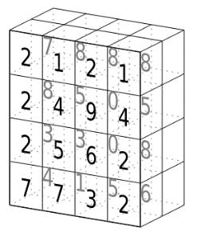

1. Convolutional Neural Networks
   1. Key concept: tensors
      1. Multidimensional arrays (note 3D tensor  
         at right)
      2. May consist of *many* dimensions (hard for  
         humans to visualize, but think of “arrays  
         nested in arrays”)
   2. CNNs Reduce images to more easily processed forms without losing features
      1. Analyzing all pixels in a high-res image with a “conventional” deep network would require *many* calculations
   3. Layers
      1. Convolution layer
         1. Kernel/Filter is “moved across” pixels in image while performing matrix multiplication
         2. Different filters may be applied to different layers
            1. RGB image has three components
            2. Each color layer is passed through a filter and summed to create a single layer which represents all three colors
         3. First CV layer captures low-level features (edges, color, etc)
         4. Additional CV layers capture high-level features (e.g. components of a face)
      2. Pooling Layer
         1. Reduces spatial size of features (less data to process
            1. Max pooling

New value is maximum value contained in pooled area

Performs de-noising (removing “clutter” in the data) and dimensionality reduction (combine features together)

* + - * 1. Average pooling

New value is average of the pooled area

Performs dimensionality reduction only

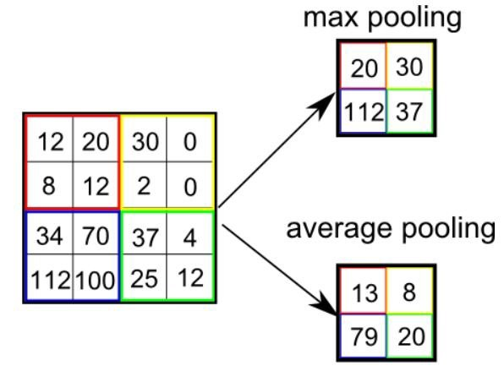

* + - 1. CNN may have multiple convolutional + pooling layer pairs
    1. Fully connected layer
       1. “Traditional” NN layers learn non-linear combinations of high-level features
  1. Drawbacks of CNNs
     1. CNNs do not encode (learn) position or orientation of an object
        1. Can learn components of a face, but not how they are arragned